Alan Yu

Organic Lab 309:03

Santanu Malakar

Experiment Gas Chromatography: Intro to GC

February 25, 2019

Purpose:

The purpose of this experiment is to measure and analyze isothermal GC data from various samples, calculate standard free energy change, standard enthalpy change, and standard entropy change of various compounds.

Equations: NONE

Mechanisms: NONE

Amounts and Properties:

Table 1: Chemical and important properties

| 1:1 Ketone and Acetone | Around 1mL |
| --- | --- |
| Acetone | Around 1mL |

Hazards and Safety:

Avoid contact and inhaling, wear gloves when dealing with the ketones and acetone. Dispose within labeled containers under the hood.

Procedure:

1. Wear goggles.

2. Prepare a known solution, using acetone as the standard that will pass quickly through the column.

· Solution 1 is a 1:1 mixture of acetone and the ketone for your section. You will not need very much sample, 1 mL total volume will be more than enough.

· Solution 2 is pure acetone.

3. Prepare the Vernier Mini GC for data collection.

a. Turn on the Mini GC.

b. Start the data-collection program, and then choose New from the File menu.

c. Tap the arrow ► in LabQuest, to bring up the Temperature-Pressure profile.

d. Set the Temperature-Pressure values according to the settings listed for Run 1:

|  | Run 1 |
| --- | --- |
| Start temperature | 40°C |
| Hold time | 5 min |
| Ramp rate | 0°C/min |
| Final temperature | 40°C |
| Hold time | 0 min |
| Total length | 5.0 min |
| Pressure | 4.0 kPa |

e. Select Done to initiate the Mini GC warm up. **Note**: A new message will appear, “Do not inject until GC is ready”, and the LED on the Mini GC is red. The Mini GC will take a few minutes to warm up and stabilize. When the Mini GC is ready for injection in Step 7, the message will read, “Inject and select Collect simultaneously”, and the LED will turn to green. Continue with Step 4 during warm up.

4. Follow the steps below to clean and flush the syringe with acetone. **Important**: The glass syringe is fragile. Be careful not to bend the needle or bend the plunger. Never pull the plunger back more than 50% of its total volume. Be careful not to bend the plunger as you press it down.

a. Depress the plunger fully.

b. Submerge the tip of the syringe needle into the vial of acetone.

c. Pull back the plunger to fill the barrel about 1/3 full of acetone. Examine the barrel of the syringe and estimate the amount of acetone in the barrel.

d. Expel the liquid onto a Kimwipe or a paper towel.

e. Repeat Steps a–d, until you are comfortable pulling up a liquid into the syringe and measuring the volume in the syringe barrel. Use a Kimwipe or a paper towel to carefully pat around the tip of the syringe needle.

5. Follow the process in Step 4 to clean and flush the syringe with Solution 1.

6. Collect a volume of the mixture for injection.

a. Submerge the needle into the vial of Solution 1 one last time.

b. Draw up approximately 0.1 mL of liquid. It is not critical that the volume be exactly 0.1 mL; a tiny bit more or less is all right.

c. After collecting your sample, gently wipe the needle from, barrel to tip, with a Kimwipe.

7. Prepare for injection and the start of data collection.

When the Mini GC has reached the correct start temperature and pressure, the message reads, “Inject and select Collect simultaneously”, and the LED on the Mini GC is green.

d. To insert the needle of the syringe into the injection port of the Mini GC, hold the syringe with one hand and steady the needle with your other hand. Insert the needle into the injection port until the needle stop is fully seated. Do not force the needle into the injection port. If the needle sticks, rotate it slightly while inserting. Do not move the plunger yet (see Figure 3).

e. Simultaneously, depress the syringe plunger and select Collect to begin data collection. Pull the needle out of the injection port immediately.

8. While the data collection proceeds, repeat Step 4 to thoroughly clean the syringe and needle. It may take more than three flushes to feel the syringe plunger move smoothly again, which is your indicator that the syringe and needle are both suitably clean.

9. Data collection will end after five minutes. You may stop the data collection early if you are certain the entire injected sample has passed through the detector.

10. Determine the retention time for your chromatogram.

· Choose Peak Integration from the Analyze menu

· Select and integrate the left-most peak. To do this, drag from a little before the peak to a point far enough to the right so that the entire peak is included. Choose Add.

· Record the displayed retention time in your data table.

· Click Cancel to return to the graph.

11. To store the data, tap the File Cabinet icon in LabQuest. Highlight the heading, Run 1, with your stylus, and replace it with the ketone name and the temperature for the run. Tap the Graph tab to return to the graph. Tap the File Cabinet icon to store the run.

12.Tap the right arrow in LabQuest to bring up the temperature-pressure profile again. This profile will be the same as for your previous run. Select Done to initiate the Mini GC profile. While the Mini GC adjusts, repeat step 4 to clean the syringe with acetone, then repeat steps 6-10 to obtain the retention time of 0.1 mL pure acetone .

13. Change the temperature profile for the next run. Continue to do isothermal runs in increments of 12°C until 112°C.

a. Tap ► in LabQuest, to bring up the Temperature-Pressure profile. Change only the temperature values. Click OK to initiate the Mini GC profile.

b. While the Mini GC adjusts to its new Temperature-Pressure profile, repeat Steps 4 and 6.

c. After the Mini GC is ready, repeat Steps 6–12 using your sample.

14. Repeat Step 13 until you have completed all seven temperature runs for your ketone.

15. When you have completed your final data collection run, turn off the Mini GC and clean up your lab area as directed.

Observations:

The only observation that was made was that

Measurements:

Table 1: GC collected values for Acetone and 1:1 Mixture

| Temp. (°C) | Acetone | 3-  methyl-2-  butanone | 3-dimethyl-2-  butanone | 4-methyl-2-  pentanone | 3-pentanone | 3-methyl-  2-butanone | 3-pentanone | 2-butanone |
| --- | --- | --- | --- | --- | --- | --- | --- | --- |
|
|
| 40 | 1.985 | 3.845 | 4.365 | 7.085 | 4.95 | 3.945 | 3.92 | 1.42 |
| 52 | 1.85 | 3.21 | 3.48 | 6.105 | 4.04 | 3.240 | 3.355 | 1.38 |
| 64 | 1.775 | 2.79 | 3.16 | 4.64 | 3.16 | 2.730 | 3.7 | 1.01 |
| 76 | 1.755 | 2.51 | 2.15 | 3.895 | 2.75 | 2.785 | 2.175 | 1.03 |
| 88 | 1.835 | 2.375 | 2.505 | 3.38 | 2.695 | 2.390 | 2.035 | 0.98 |
| 100 | 1.73 | 2.31 | 1.94 | 3.545 | 2.465 | 2.255 | 1.865 | 0.93 |
| 112 | 1.91 | 2.19 | 2.39 | 3.15 | 2.505 | 2.200 | 1.655 | 1.13 |

Data and Calculations:

Sample Calculations:

For 3-methyl-2-butanone: (same for the other solutions)

k = $\frac{3.845 - 1.985}{1.985}=.937$

Kc = $.937 * 200 = 187.41$

T in Kelvin = 40 + 273.15 = 313.15K

ΔG = -RTln(Kc) → -13.625 kJ/mol

ΔG of 25 degrees C: Equation is: y = -.0317x + -23.9

Y is ΔG and the coefficient of x is ΔS and the b in the equation is the ΔH.

25 → K = 25 + 273.15 → 293.15K ← Plug in for x

ΔG = -33.193 kJ

Discussion:

Since the ΔG for the 2-butanone sample, could not be calculated, there were no values indicated and no graph was provided for the data set. For the 3-pentanone data set, the 112 degrees C value had a ΔG that was not able to be calculated. For ΔG at 25 degrees Celsius of 2-butanone, it can not be calculated due to not being able to calculate a ΔG value regularly.

Conclusions:

Some sources of error for this experiment could have been that the sample was injected before pressing collect data on the machines which could yield a different retention time or that the machine was not functioning properly and that the malfunction was not found until after conducting the experiment. An example of injecting before pressing collect data could be from the 3-dimethyl-2-butanone trial where from 100 degrees to 112 degrees the retention time went up. Acetone data was all the same for each sample considering the variation that can happen from each section and this was to make sure the data could be uniform as possible.

Data Analysis (Exercises):

1. Table 2: 3-methyl-2-butanone 1:1 mix test (COMBINED)

| Temp (C) | tR (min) | tM (min) | k | Kc | -T (K) | ΔG (kJ/mol) | ΔG at 25 Celsius |
| --- | --- | --- | --- | --- | --- | --- | --- |
| 40.0000 | 3.8950 | 1.9850 | 0.9622 | 192.4433 | -313.1500 | -13.6932 | -33.193 kJ |
| 52.0000 | 3.2250 | 1.8500 | 0.7432 | 148.6486 | -325.1500 | -13.5206 |
| 64.0000 | 2.7600 | 1.7750 | 0.5549 | 110.9859 | -337.1500 | -13.1995 |
| 76.0000 | 2.6475 | 1.7550 | 0.5085 | 101.7094 | -349.1500 | -13.3824 |
| 88.0000 | 2.3825 | 1.8350 | 0.2984 | 59.6730 | -361.1500 | -12.2770 |
| 100.0000 | 2.2825 | 1.7300 | 0.3194 | 63.8728 | -373.1500 | -12.8924 |
| 112.0000 | 2.1950 | 1.9100 | 0.1492 | 29.8429 | -385.1500 | -10.8738 |

Figure 1: 3-methyl-2-butanone Graph

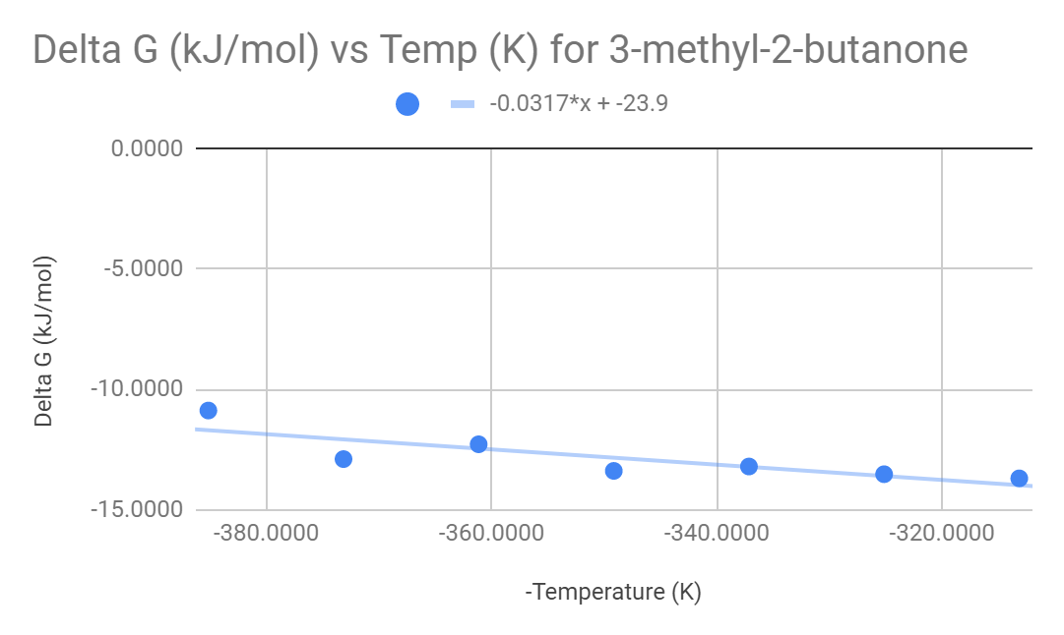

Table 3: 3-dimethyl-2-butanone 1:1 mix test

| Temp (C) | tR (min) | tM (min) | k | Kc | -T (K) | ΔG (kJ/mol) | ΔG at 25 Celsius |
| --- | --- | --- | --- | --- | --- | --- | --- |
| 40.0000 | 4.3650 | 1.9850 | 1.1990 | 239.7985 | -313.1500 | -14.2668 | -40.65 kJ |
| 52.0000 | 3.4800 | 1.8500 | 0.8811 | 176.2162 | -325.1500 | -13.9807 |
| 64.0000 | 3.1600 | 1.7750 | 0.7803 | 156.0563 | -337.1500 | -14.1561 |
| 76.0000 | 2.1500 | 1.7550 | 0.2251 | 45.0142 | -349.1500 | -11.0510 |
| 88.0000 | 2.5050 | 1.8350 | 0.3651 | 73.0245 | -361.1500 | -12.8835 |
| 100.0000 | 1.9400 | 1.7300 | 0.1214 | 24.2775 | -373.1500 | -9.8952 |
| 112.0000 | 2.3900 | 1.9100 | 0.2513 | 50.2618 | -385.1500 | -12.5436 |

Figure 2: 3-dimethyl-2-butanone Graph

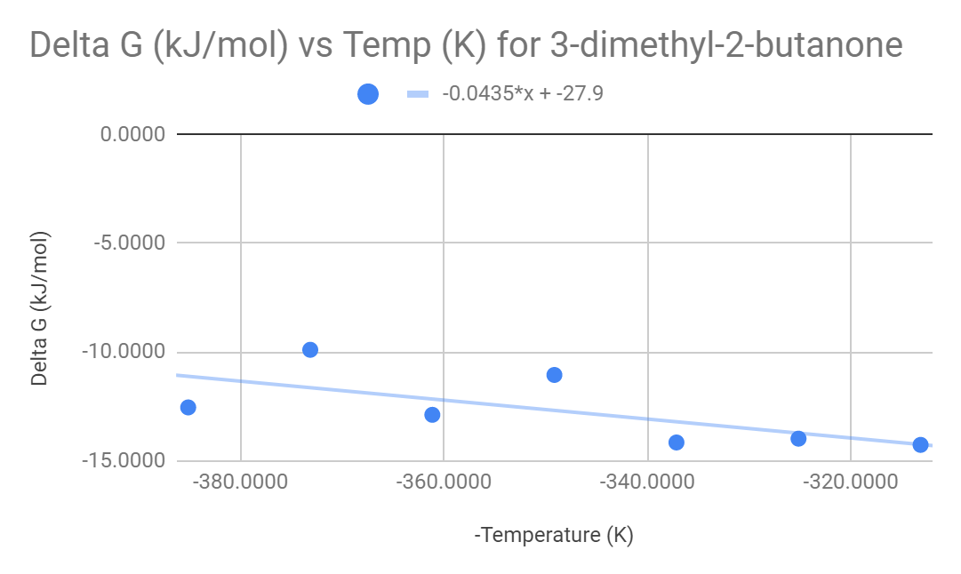

Table 4: 4-methyl-2-pentanone 1:1 mix test

| Temp (C) | tR (min) | tM (min) | k | Kc | -T (K) | ΔG (kJ/mol) | ΔG at 25 Celsius |
| --- | --- | --- | --- | --- | --- | --- | --- |
| 40.0000 | 7.0850 | 1.9850 | 2.5693 | 513.8539 | -313.1500 | -16.2511 | -21.427 kJ |
| 52.0000 | 6.1050 | 1.8500 | 2.3000 | 460.0000 | -325.1500 | -16.5745 |
| 64.0000 | 4.6400 | 1.7750 | 1.6141 | 322.8169 | -337.1500 | -16.1935 |
| 76.0000 | 3.8950 | 1.7550 | 1.2194 | 243.8746 | -349.1500 | -15.9559 |
| 88.0000 | 3.3800 | 1.8350 | 0.8420 | 168.3924 | -361.1500 | -15.3922 |
| 100.0000 | 3.5450 | 1.7300 | 1.0491 | 209.8266 | -373.1500 | -16.5861 |
| 112.0000 | 3.1500 | 1.9100 | 0.6492 | 129.8429 | -385.1500 | -15.5826 |

Figure 3: 4-methyl-2-pentanone Graph:

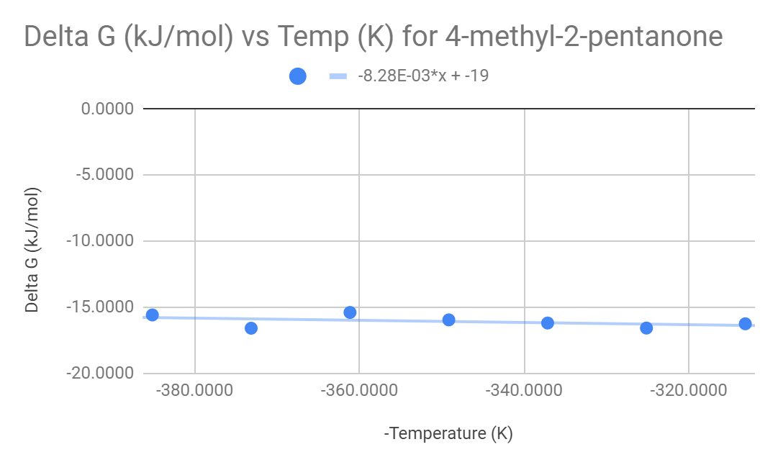

Table 5: 3-pentanone 1:1 mix test (COMBINED)

| Temp (C) | tR (min) | tM (min) | k | Kc | -T (K) | ΔG (kJ/mol) | ΔG at 25 Celsius |
| --- | --- | --- | --- | --- | --- | --- | --- |
| 40.0000 | 4.4350 | 1.9850 | 1.2343 | 246.8514 | -313.1500 | -14.2835 | -52.851 kJ |
| 52.0000 | 3.6975 | 1.8500 | 0.9986 | 199.7297 | -325.1500 | -14.2720 |
| 64.0000 | 3.4300 | 1.7750 | 0.9324 | 186.4789 | -337.1500 | -14.6175 |
| 76.0000 | 2.4625 | 1.7550 | 0.4031 | 80.6268 | -349.1500 | -12.4810 |
| 88.0000 | 2.3650 | 1.8350 | 0.2888 | 57.7657 | -361.1500 | -11.4433 |
| 100.0000 | 2.1650 | 1.7300 | 0.2514 | 50.2890 | -373.1500 | -11.1531 |
| 112.0000 | 2.0800 | 1.9100 | 0.0890 | 17.8010 | -385.1500 | #NUM! |

Figure 4: 3-pentanone Graph

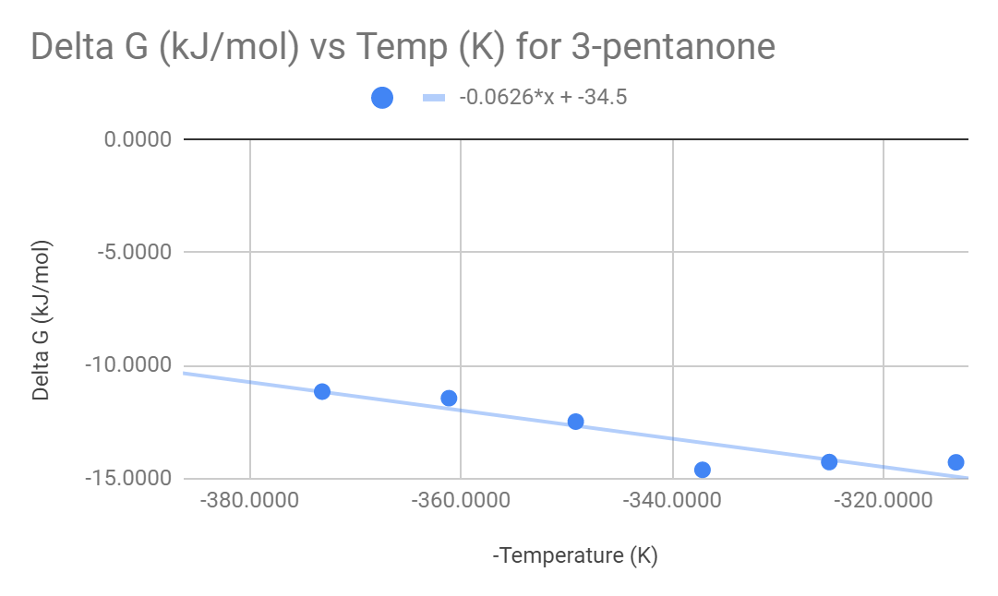

Table 6: 2-butanone 1:1 mix test

| Temp (C) | tR (min) | tM (min) | k | Kc | -T (K) | ΔG (kJ/mol) |
| --- | --- | --- | --- | --- | --- | --- |
| 40.0000 | 1.4200 | 1.9850 | -0.2846 | -56.9270 | -313.1500 | #NUM! |
| 52.0000 | 1.3800 | 1.8500 | -0.2541 | -50.8108 | -325.1500 | #NUM! |
| 64.0000 | 1.0100 | 1.7750 | -0.4310 | -86.1972 | -337.1500 | #NUM! |
| 76.0000 | 1.0300 | 1.7550 | -0.4131 | -82.6211 | -349.1500 | #NUM! |
| 88.0000 | 0.9800 | 1.8350 | -0.4659 | -93.1880 | -361.1500 | #NUM! |
| 100.0000 | 0.9300 | 1.7300 | -0.4624 | -92.4855 | -373.1500 | #NUM! |
| 112.0000 | 1.1300 | 1.9100 | -0.4084 | -81.6754 | -385.1500 | #NUM! |

1. In each respective section.
2. In each respective table.
3. Table 7: Table for Figure 6

| Compound | # Of Carbon Atoms | ΔG at 25 Celsius (kJ) |
| --- | --- | --- |
| 2-butanone | 4 | N/A |
| 3-pentanone | 5 | -52.851 |
| 3-methyl-2-butanone | 5 | -33.193 |
| 3-dimethyl-2-butanone | 6 | -40.65 |
| 4-methyl-2-pentanone | 6 | -21.427 |

Figure 6: ΔG (kJ/mol) at 25 Celsius vs number of Carbons for all 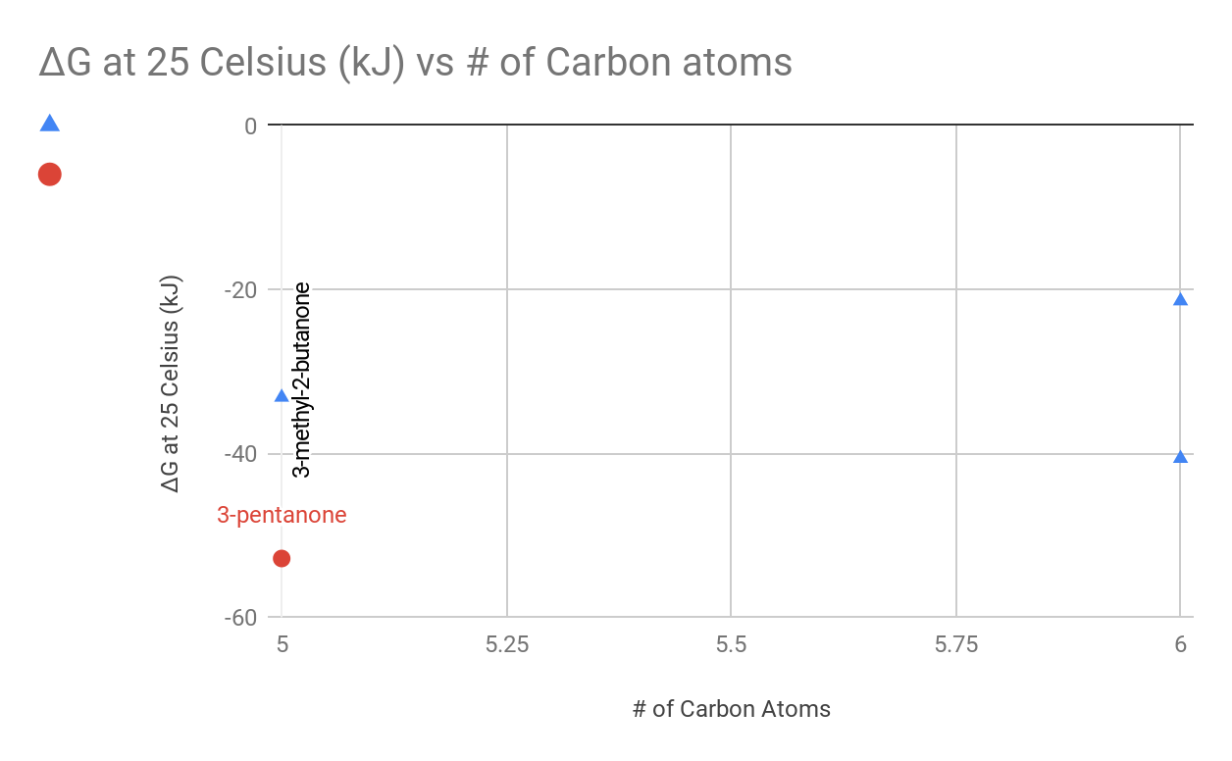

Legend: Triangles are compounds with branched carbons, circles are compounds without branched carbons.

The ones have branched methyls have ΔG values that are closer to 0 kJ than that of the ones without branched methyls.

1. Since each of the ΔG that were calculated were negative at room temperature, all of the compounds can be spontaneous in order for the gas chromatography experiment to be conducted. If the compounds did not have negative ΔG values, then the compound couldn’t have gotten retention times in the gas chromatogram.